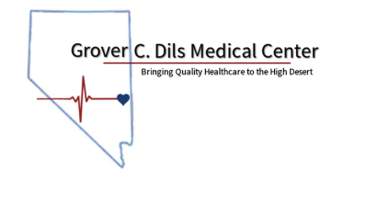

Grover C. Dils Medical Center Grover C. Dils Medical Center is looking to employ a dedicated and reliable maintenance assistant to maintain our facilities and perform regular maintenance tasks.
Location: CALIENTE, NV
Hours: 40 hours a week – FULL TIME with benefits
Wage: Depending on experience

Maintenance Assistant Responsibilities:
- Completing minor repair work, which includes repairing doors, locks, door frames and handles as well as replacing light bulbs, sockets, switches, and window glass.
- Performing basic plumbing tasks, which includes unclogging drains as well as fixing leaking faucets and toilets.
- Performing regular cleaning duties, which includes sweeping, dusting, mopping, and vacuuming.
- Maintaining all outdoor areas: lawn care, as well as shoveling snow and ice as required.
- Inspecting control panels and electrical wiring to detect any issues that require immediate attention.
- Taking inventory of maintenance supplies and notifying the Supervisor of low or depleted supplies.
- Promptly responding to requests for emergency repairs and clean-ups.
- Ensuring that all maintenance equipment is in good working order.

Minimum Requirements:
- High school diploma or GED.
- Sound knowledge of basic plumbing, carpentry, and electrical wiring.
- Proven general maintenance experience.
- The ability to safely operate hand and power tools as well as cleaning equipment.
- The ability to lift heavy objects.
- Strong problem-solving skills.
- Excellent time management skills.
- Effective communication skills.
- Good hand-eye coordination.
Applications are available on line at www.gcdmc.org, or you may pick up the application in person Monday thru Friday from 8am-4pm in our Human Resources office located in the Administration building in Caliente. Applications must be complete and submitted to Katherine Lucchesi, HR Director by email: hr@gcdmc.org, by mail to: P.O. Box 1010 Caliente, NV 89008 or delivered in person.
Questions regarding the position may be directed to Erik Bart at 775/726-8025.
Grover C. Dils Medical Center is an Equal Opportunity Employer.

