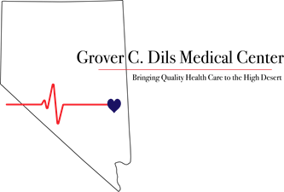

Lincoln County Community Health Fair

October 4, 2025

Grover C. Dils Medical Center is proud to present the 2025 Community Health Fair. If you/your business are interested in setting up a booth for this event, please complete this brief form. All booths will be assigned and information emailed before the event.
Hosted at the Caliente Fire Station
Set up: 6:00AM – 8:00AM
Event Hours: 8:00AM – 12:00PM
Break Down: 12:00PM – 1:00PM

Resource/Business:
Business Name _____________________________________________________________________________________
Phone ____________________________________________________________________________________________
Mailing Address _____________________________________________________________________________________
Street City State Zip Code
Please write a brief description of your business/resource:
______________________________________________________________________________________________________________________________________________________________________________________________________________________________________________________________________________________________________
Please Select One: 6’ Table ☐ 10x10 Booth ☐ Electricity Needed: ☐ YES ☐ NO
Additional Requests: ________________________________________________________________________________
__________________________________________________________________________________________________
Main Contact (Person who will be on site for the Health Fair):
Name _____________________________________________________________________________________________
Phone ____________________________________________________________________________________________
Email _____________________________________________________________________________________________
Please send your completed vendor applications to: mpeterson@gcdmc.org
Should you have any questions, please contact Megan Peterson (775) 726-8076

